EENG 385 - Electronic Devices and Circuits

Frequency Domain: Active Filters

Lab Handout

# Objective

The objective of this lab is to study the design of the filters on the audio board and measure their performance.

# Filter Background

An ideal filter allows a range of frequencies to pass through the filter unchanged. This range of frequencies is called the passband. Frequencies outside the passband cannot pass through the filter. Thus, a filter is an electronic device whose output depends on the frequency of the input signal.

In the real world, ideal filters do not exist. Instead, real filters reduce, but do not eliminate, signals outside the passband. The reduction of a signal’s amplitude from input to output is called attenuation and is measured in units of decibels.

* A positive decibel value means the amplitude of the output is larger than the input.
* A decibel value of 0 means the output has the same amplitude as the input.
* Negative decibels means that the amplitude of the output is smaller than the input.

The goal of this lab is to design, simulate, assemble and test filters three filters shown in Figure 1 to achieve specific performance goals.

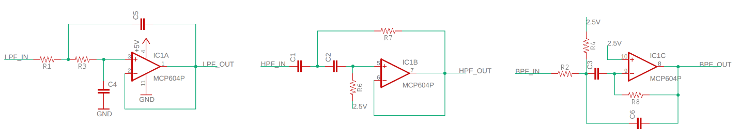

Figure : The Audio board comes setup with three filters. From left to right, low pass, high pass and band pass. Your task in this lab is to select component value to achieve specific performance goals.

To complete this lab, use the How To documents posted on our class Canvas page. I’d suggest completing the work in the order listed in the **Turn In** section.

The answer is given below.

* + When the POT is at 80% the high side of the POT is 0.8*100kΩ = 80kΩ. The low side of the POT is 0.2*100kΩ = 20kΩ. The parallel arrangement of an 80kΩ and 20kΩ resistor is equal to (80k*20k)/(80k + 20k) = 16kΩ
  + The corner frequency is given
  + The Bode plot from MultiSim is given below and has a -3dB frequency of 10Hz.

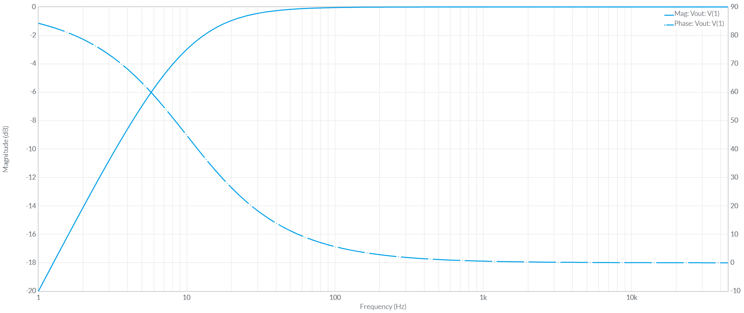

# Turn in:

Make a record of your response to numbered items below and turn them in a single copy as your team’s solution on Canvas using the instructions posted there. Include the names of both team members at the top of your solutions. Use complete English sentences to introduce what each of the following listed items (below) is and how it was derived.

## The Level Shifter

Since we will be using the level-shifter as a front-end for FRA of the three filters, we need to make sure that it does not introduce any unwanted attenuation of the input signal. Do this by measuring the frequency response of the level-shifter using the oscilloscopes.

Complete the following:

* **Construct your level shifter filter on your Audio board**
  + **Instructions in:** *freqDomain howTo04 ConstructFilter*
* **Make a Bode plot of your level shifter**
  + **Instructions in:** *freqDomain howTo00 LevelShifter.pdf*
  + **Instructions in:** *freqDomain howTo06 Measure FreqSweep.pdf*

## Design a Low Pass Filter:

Design a low pass filter with the following requirements using the instructions in

*freqDomain howTo01 DesignFilter.pdf*

**Requirements:**

Passband:

* Gain 0dB

* dB at Hz -3dB @ 220Hz

Stopband:

* dB at Hz -40dB @ 2.2kHz

Filter response: Set passband ripple to 1dB

Use: +Vs=5V -Vs=0V

Use: E6 resistor and capacitors with 5% tolerances

Complete the following:

* **Simulation Bode Plot – Point by Point**
  + **Instructions in:** *freqDomain howTo02 Simulate PointByPoint.pdf*
* **Simulation Bode Plot – Frequency Sweep**
  + **Instructions in:** *freqDomain howTo03 Simulate FreqSweep.pdf*
* **Construct your low pass filter on your Audio board**
  + **Instructions in:** *freqDomain howTo04 ConstructFilter*
* **Circuit Bode Plot – Point by Point**
  + **Instructions in:** *freqDomain howTo05 Measure PointByPoint.pdf*
* **Circuit Bode Plot – Frequency Sweep using FRA**
  + **Instructions in:** *freqDomain howTo06 Measure FreqSweep.pdf*

## Design a High Pass Filter:

Design a high filter with the following requirements. Use the Analog Design Wizard to determine the component values.

**Requirements:**

Passband:

* Gain 0dB

* dB at Hz -3dB @ 880Hz

Stopband:

* dB at Hz -40dB @ 88Hz

Filter response: Set passband ripple to 2dB

Use: +Vs=5V -Vs=0V

Use: E6 resistor and capacitors with 5% tolerances

Ignore the mid-supply voltage reference circuit suggested by the Filter Wizard. Our PCB circuit uses the 2.5V Zener as the REF signal.

Complete the following:

* **Simulation Bode Plot – Frequency Sweep**
  + **Instructions in:** *freqDomain howTo03 Simulate FreqSweep.pdf*
* **Construct you high pass filter on your Audio board**
  + **Instructions in:** *freqDomain howTo04 ConstructFilter*
* **Circuit Bode Plot – Frequency Sweep using FRA**
  + **Instructions in:** *freqDomain howTo06 Measure FreqSweep.pdf*

## Design a Band Pass Filter:

Design a band pass filter with the following requirements. Use the Analog Design Wizard to determine the component values.

**Requirements:**

Passband:

* Gain 0dB

* dB at Hz -3dB @ 200Hz

Stopband:

* dB at Hz -20dB @ 2kHz

Center Frequency: 440Hz

Filter response: 2nd order Butterworth

Use: +Vs=5V -Vs=0V

Use: E6 resistor and capacitors with 5% tolerances

Ignore the mid-supply voltage reference circuit suggested by the Filter Wizard. Our PCB circuit uses the 2.5V Zener as the REF signal.

Complete the following:

* **Simulation Bode Plot – Frequency Sweep**
  + **Instructions in:** *freqDomain howTo03 Simulate FreqSweep.pdf*
* **Construct you band pass filter on your Audio board**
  + **Instructions in:** *freqDomain howTo04 ConstructFilter*
* **Circuit Bode Plot – Frequency Sweep using FRA**
  + **Instructions in:** *freqDomain howTo06 Measure FreqSweep.pdf*

## Demo:

* Connect an audio source into the audio jack (Husker Scope).
* Use jumper wire to connect the LEFT audio header pin to the LEVEL input header pin.
* Use jumper wire to connect the LEVEL output header pin to the LPF input header pin.
* Use jumper wire to connect the LPF output header pin to the AMPIN input header pin.
* Connect a speaker to the SPEAKER+ and SPEAKER- pins.
* Adjust the signal frequency to hear the audio output produced. Note the frequency where the volume starts to drop off – this should correspond to the corner frequency of the LPF filter.
* Try replacing the LPF with the BPF and HPF to hear the effect produced and note the frequency where the volume starts to change.